A Recipe For:

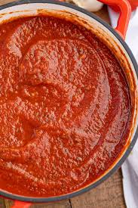 

# **Homemade Marinara Sauce**

**From the Kitchen of:** Mom

**Servings:** 2 cups

**Prep Time:** 5 min **Bake Time:** 35 Minutes **Bake Temp:**

**Ingredients:**

* 1 Tbsp olive oil
* 3 cloves garlic minced
* 5 fresh tomatoes (1 to 1.5 lbs diced)
* 2 Tbsp fresh basil finely chopped
* 1 Tbsp honey
* ½ tsp salt
* ¼ tsp ground black pepper
* 3 sprigs of parsley

**Instructions:**

1. Heat oil in a medium saucepan over medium heat. Add garlic and cook until soft and fragrant, about 2 minutes.
2. Stir in dices tomatoes with skins and allow to simmer uncovered until tomatoes have mostly broken down, about 25 minutes. Stir often to prevent burning.
3. Stir in basil, honey, salt, pepper and parsley (stem and leaves intact).
4. Continue simmering about 10 minutes. Carefully remove sprigs of parsley with a fork.
5. You can serve like this, kind of chunky, or puree it in a food processor/blender for a smoother sauce. Remember to take the small top of the blender lid off and cover with a paper towel so that the sauce doesn’t explode due to the heat of the sauce.

**NOTE:**

Use maple syrup instead of honey to make this recipe vegan.